**Online mobile shop management**



Introduction of project

In online mobile shop we required entities such as:

1.mobile id

2.mobile name

3.company name

4.price

5.mobile description

In this project we have an website where we can add our phone details all the data will be stored in database thus with the help of it we can check our data of our phone which has been stored. We can also delete our data into it. Or update it. For this mobile shop I have first created database as mobile shop and in that mobile shop I have added tables named details.

Next I have created restful webservice named DetailsFacadeRest

code

DetailsFascadeRest.java

/*

* To change this license header, choose License Headers in Project Properties.

* To change this template file, choose Tools | Templates

* and open the template in the editor.

*/

package phone.service;

import java.util.List;

import javax.ejb.Stateless;

import javax.persistence.EntityManager;

import javax.persistence.PersistenceContext;

import javax.ws.rs.Consumes;

import javax.ws.rs.DELETE;

import javax.ws.rs.GET;

import javax.ws.rs.POST;

import javax.ws.rs.PUT;

import javax.ws.rs.Path;

import javax.ws.rs.PathParam;

import javax.ws.rs.Produces;

import javax.ws.rs.core.MediaType;

import mobile1.Details;

/**

*

* @author macbookpro

*/

@Stateless

@Path("mobile1.details")

public class DetailsFacadeREST extends AbstractFacade<Details> {

@PersistenceContext(unitName = "ca2projectwsPU")

private EntityManager em;

public DetailsFacadeREST() {

super(Details.class);

}

@POST

@Override

@Consumes({ MediaType.APPLICATION_JSON})

public void create(Details entity) {

super.create(entity);

}

@PUT

@Path("{id}")

@Consumes({ MediaType.APPLICATION_JSON})

public void edit(@PathParam("id") Integer id, Details entity) {

super.edit(entity);

}

@DELETE

@Path("{id}")

public void remove(@PathParam("id") Integer id) {

super.remove(super.find(id));

}

@GET

@Path("{id}")

@Produces({ MediaType.APPLICATION_JSON})

public Details find(@PathParam("id") Integer id) {

return super.find(id);

}

@GET

@Override

@Produces({ MediaType.APPLICATION_JSON})

public List<Details> findAll() {

return super.findAll();

}

@GET

@Path("{from}/{to}")

@Produces({ MediaType.APPLICATION_JSON})

public List<Details> findRange(@PathParam("from") Integer from, @PathParam("to") Integer to) {

return super.findRange(new int[]{from, to});

}

@GET

@Path("count")

@Produces(MediaType.TEXT_PLAIN)

public String countREST() {

return String.valueOf(super.count());

}

@Override

protected EntityManager getEntityManager() {

return em;

}

}

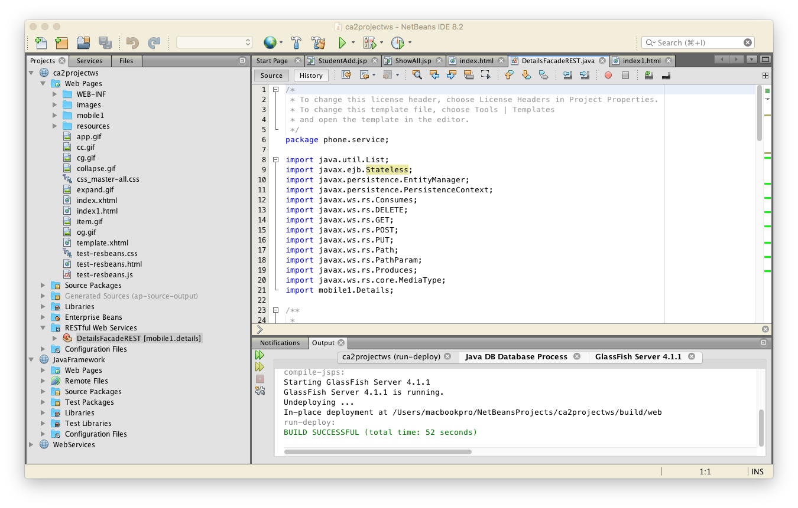

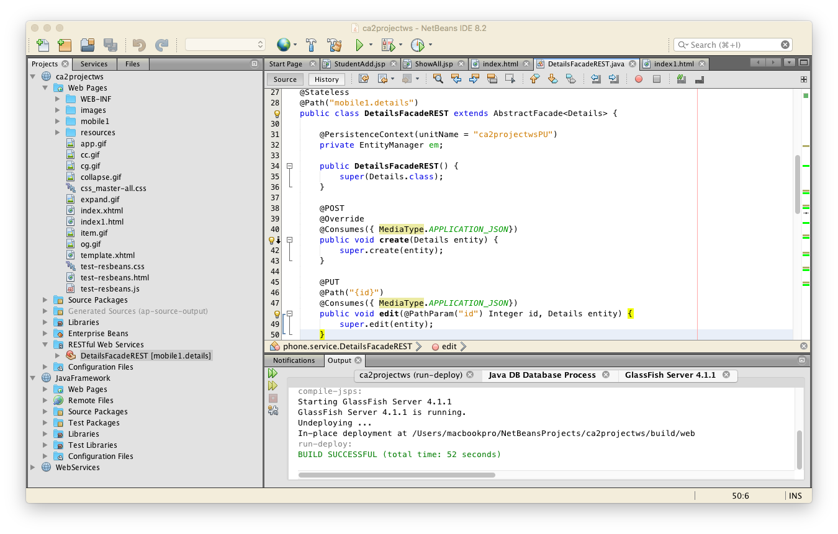

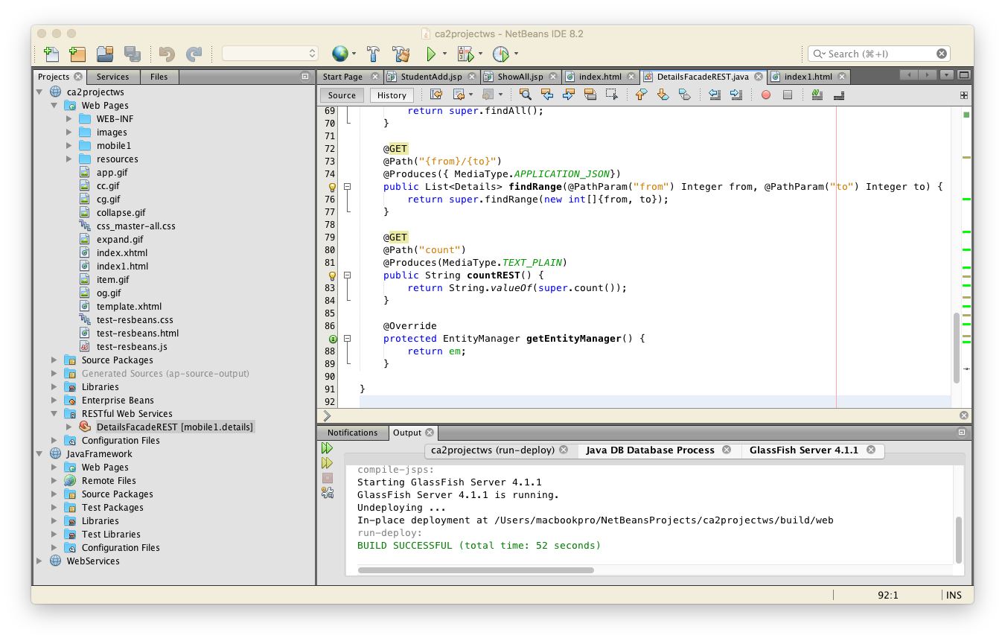

Mobiles.html

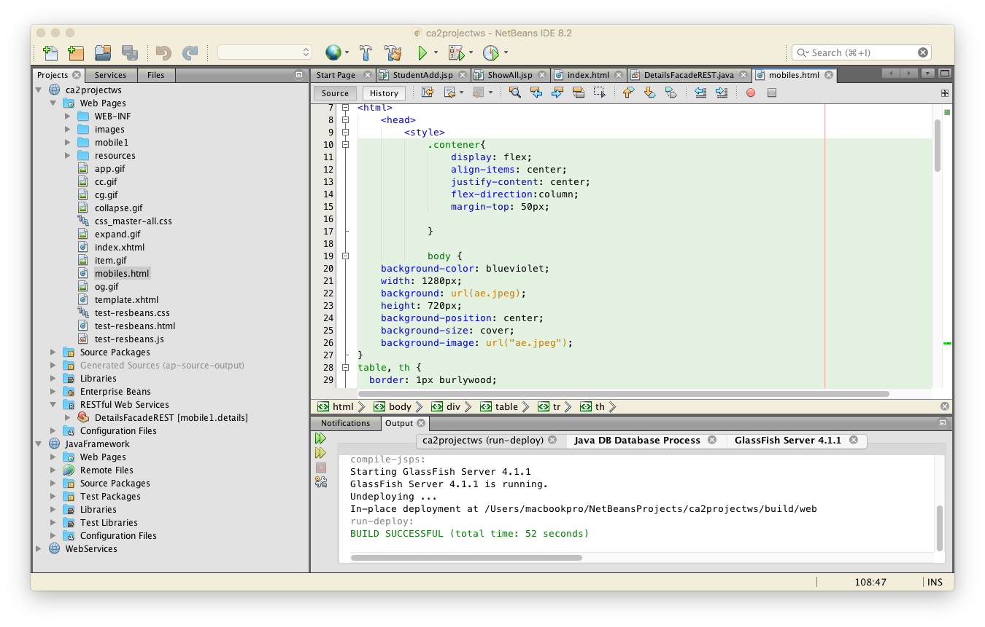

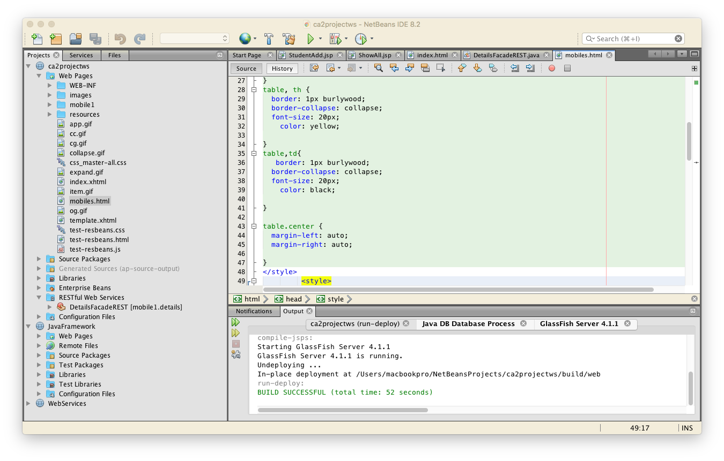

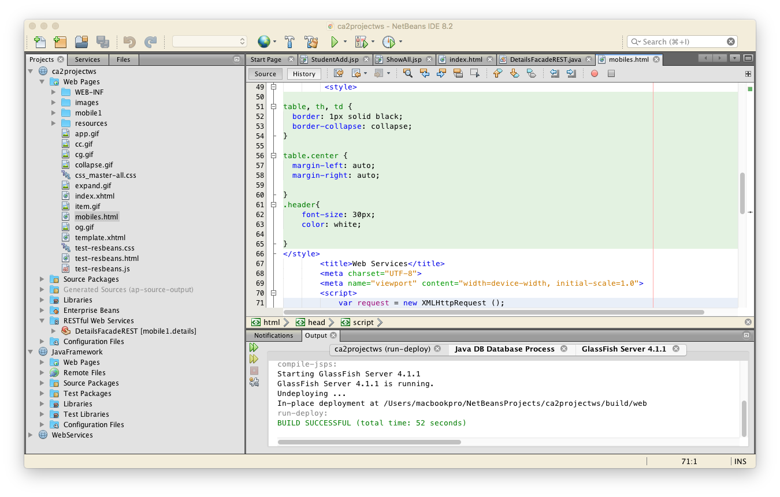

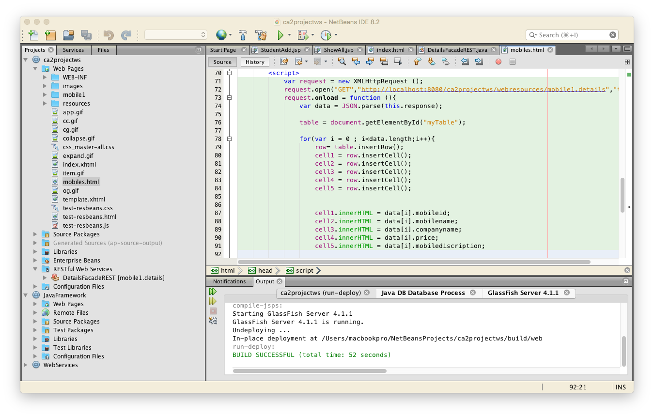

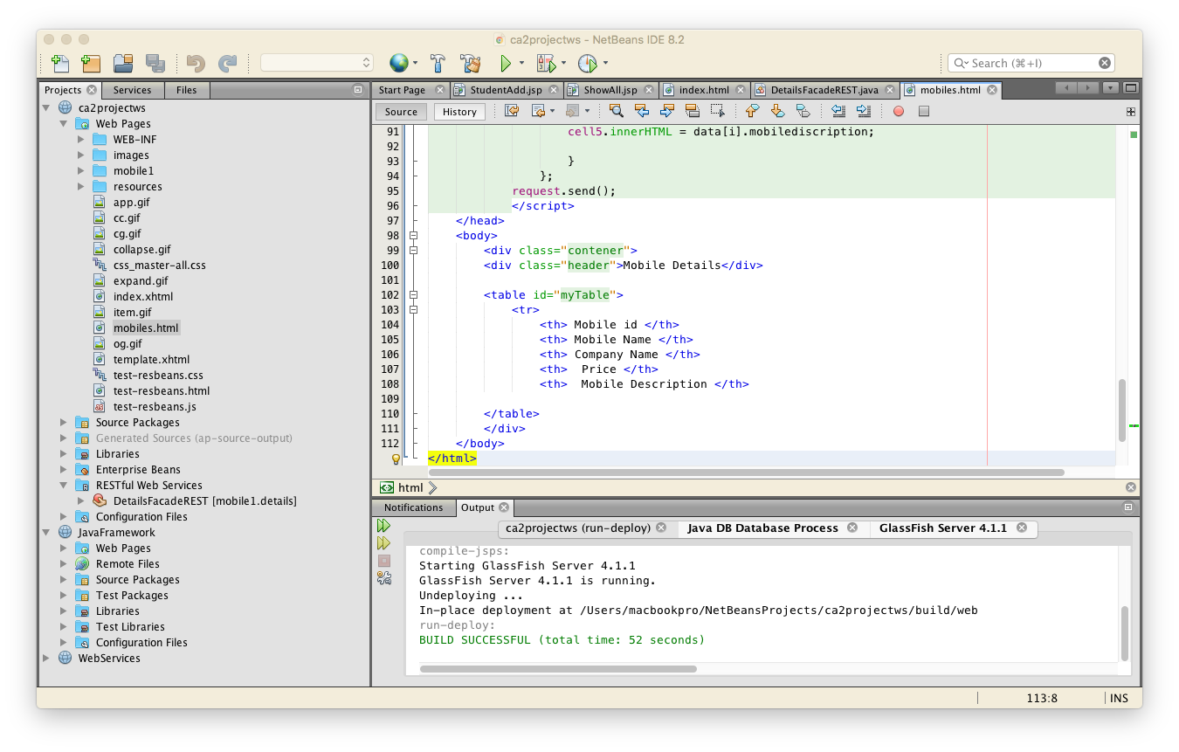

**Output**

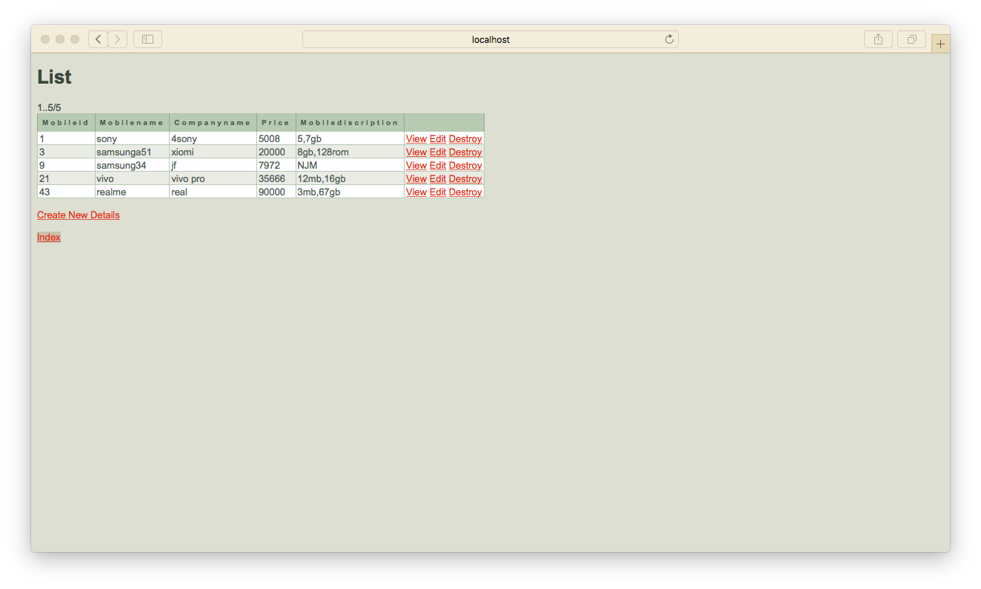

**View**

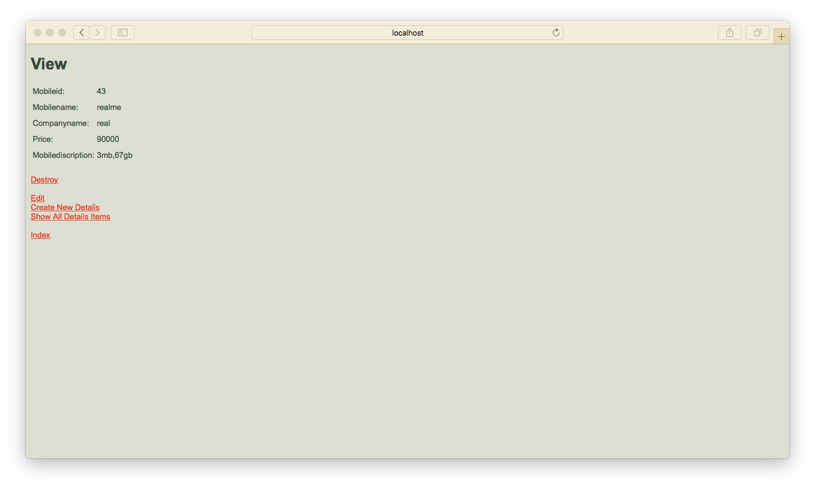

**Delete data**

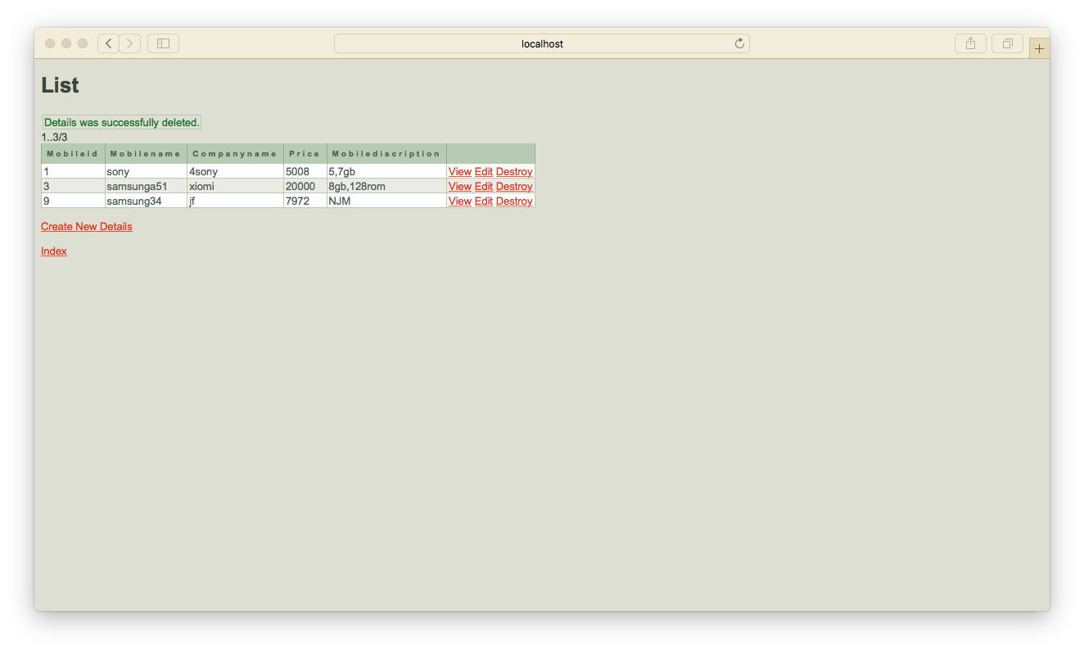

**Update data**

